It's Not Too Late For You
October 12th, 2021

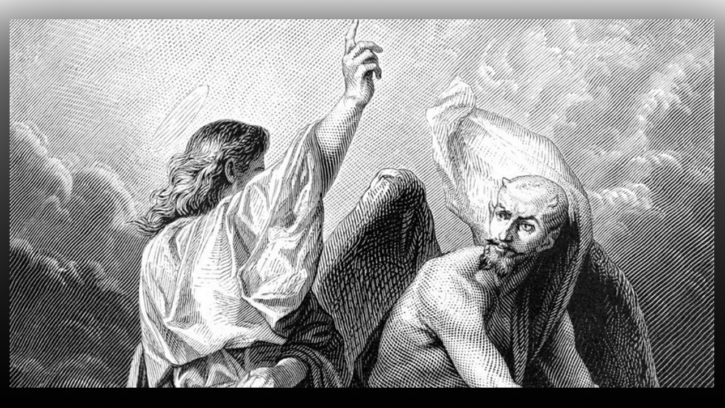
Lord Jesus, we lift up the shield of faith against all the fiery darts of the enemy and use Your Words against all the forces of evil. We pray in complete dependence upon You. Thank You for the conversion of our enemies and the lost. Amen

Blessed Mother began speaking to Mother Clare, “People have been fed lies that Jesus and Satan were brothers. Satan is an angel who was once privileged to lead worship in Heaven, given the beautiful name of Lucifer, until inequity was found in him and he became jealous of God, recruiting one third of the angels in Heaven to be wicked and fight against all God stood for, destroying all of creation and despising men who were the Lord’s crowning creation.

“Do not equate sickness, disease and death with God. All of that, comes from Satan and man’s cooperation with his evil agendas, thinking that Satan has some kind of power and kingdom and if they do his bidding, he will reward them. Then when the time comes, they die, the demons drag them down to hell and torment them with unthinkable tortures. Satan laughs them to scorn, “You knew I was a liar, but you were stupid and believed all my lies.” Then he laughs, and curses them for their stupidity. I’m speaking to you who believes these lies. Satan indeed has a kingdom, the Lake of Fire prepared for him and all who swallow his lies and dedicate themselves to serving him.

“It’s not too late for you to repent, look at John Ramirez, read his books and see how Satan deceived him, it’s not too late for you to turn around. We are all praying for you. Know that Jesus loves you in spite of the things you’ve done, He is ready to forgive you, and the work He has for you is more wonderful and fulfilling, rather than swimming in constant curses, bitterness and hatred. He will bath you in His grace until you are clean and filled with His love. He will pour oil upon the wounds of the past and heal you. He was not the one who devised the terrible things that happened to you as a child. Satan is. Rather He wants to rewrite your history and bring healing and joy into your lives.

“You have nothing to lose but eternity in Hell, constantly burning and being tortured, only for your limbs and skin to grow back to be tormented again. He will protect you if you give your life to Him. He has had His eye on you your whole life and has been praying you would come back to Him before it’s too late. Please, please, believe me, He is the only one who has ever loved you.

“John Ramirez was choosing principalities for New York City, he got tired of cursing and asked Satan for a break. So, Satan made him completely blind for 12 months. Not my Jesus, He gives me rest when I need it. Satan visited John in his room every night, grooming him to be his man. He played on John’s need for a father’s love, he was a third-generation witch. Satan played nice with him, but when he asked for time off, he played hard ball. Satan has taught you how to lie, steal and cheat, how to kill and destroy. Jesus will teach you how to love yourself and be in love with the God who cares for you, who created you, who is calling you in the midst of your sins. Did you know that many who embrace witchcraft were born to be prophets of God? But Satan injured them at a very tender age and trapped them into a culture of cursing and death, only to end in eternal torment.

“When you do business with a person, don’t you check their reputation and if they tell the truth? After all, if you’re looking for a car you won’t go to a dealer who has a bad reputation for cheating people. You’ll go to a guy who is square and honest and has a proven track record. Well Satan has a proven track record, lies, murder, stealing, destroying and deceiving. He has taught you to be the same. And you are going to trust your eternity to his word when he tells you that lame story that Jesus is Satan’s brother? And you have riches and everything you ever wanted when you die?

“He promises you a kingdom, but he teaches you how to destroy your life. Do you really think payday is coming from him? He is the father of lies, don’t wait till it is too late to find out. Think it through, he has preplanned his agenda for you, total destruction, he is enraged with jealousy and hatred because God loves you.

“Come to Jesus and He will protect you from Satan as well. All you have to do is tell Him, “If you’re real, show me,” and I believe He will make you tired of your murderous life, cleanse you of your past, and call you His dearly beloved son. “Jesus, if you are real please show me,” and see what happens. You see, Hell was not created for you, it was created for the fallen angels who were kicked out of Heaven with Lucifer. Heaven WAS created for you, so God could have you in a place of great happiness. It’s your choice.”

